River East Ringette Association
Policies and Guidelines

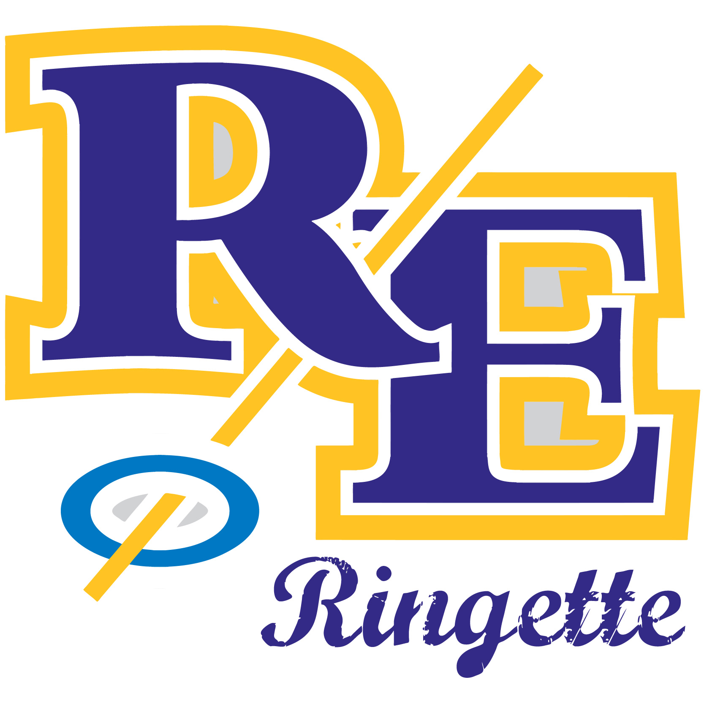

May 2018

Table of Contents

Registration ………………………………………………… 1
Coaching ………………………………………………... 1
Player Development ………………………………………. 1
Appeals ……………………………………………………………… 2
Ice ………………………………………………… 2
Officials ………………………………………………… 2
Bingo ………………………………………………… 3
Westerns/Nationals ………………………………………. 3
Refund Policy …………………………………………………. 4

Registration
All players are required to register at their home community centre and pay the current fee set out by the RERA board for their age level plus the club fee set at community centre. This does not guarantee that you will play out of your home community centre.
If a volunteer fee is also required it is to be done at the home community centre.
RERA will pay any late registration fees assessed for new players only.
All players on a AA team must also register at their home community centre and follow the volunteer fee schedule as set out their home community centre.
All monies collected for registration at each Community Club will be transferred to RERA by procedure established by the RERA Treasurer and approved by the RERA Executive.
Transfer of funds to other community clubs for payment of ice or registration will be made by RERA.
In regards to players who are transferred to or from RERA, if the cost difference is less than $50 then RERA wouldn’t give a refund as we offer free practices which are included with our registration.
If funds are available, RERA will purchase a small item to be given out to those who register. This is available at time of registration.

Coaching
All individuals wanting to coach a team hosted by RERA must apply through a procedure set out by the Director of Coaching.
All coaches are chosen by the Director of Coaching & club convenors. If there is a conflict of interest the final decision is made by the RERA Executive.
Once head coaches are chosen, they are responsible for selecting their own bench staff. If Assistant and Junior Coaches will be used they must be selected from those who submitted their application to RERA.
A pre-season coach meeting is held prior to the Town Hall Meeting held by WRL. If this cannot be accommodated, all necessary information is shared with the coaches through another avenue.
RERA will pay for any refusals by a club for reimbursement of coaching clinic fees of rostered coaching staff to a maximum of four per team per year. Teams will be responsible for payment of any coaching requirements beyond four.
All coaches may be evaluated through an evaluation form created by the Director of Coaching and approved by the RERA Executive. All documents are to be kept secure by the Director of Coaching or in case of a conflict, the current President of RERA.

Player Development
RERA will provide a rust buster skate to all R4U, U10, U12, U14, U16 & U19 players registered with RERA prior to tryouts and assessments.
RERA will provide at least one goalie clinic for all goalies in the RERA area with RERA paying for half of the costs of this endeavor.
Depending on registration numbers, RERA will host at least one A team. If numbers don’t support, amalgamation with an aligning association will occur. Ice availability, coaches and goalies will all be determining factors in the decision process.
All amalgamations are approved at the WRL amalgamation meeting held after registration and prior to tryouts.
RERA has a tryout evaluation that is approved each year by the RERA Executive. This evaluation was established to ensure a transparent process is followed.
Tryout fees will be charged to those wishing to tryout. All players must pay the tryout fee prior to going on the ice for the first time. This fee will cover the cost of the ice time and on-ice instructors.
If an underage player wishes to tryout, they must finish in the top five of all evaluated in order to be placed on the team.
Evaluators are used to ensure the process is unbiased. If funds are available, RERA will hire evaluators to assist in the assessment of players.
If numbers support and two teams need to be made at the same age level, separate evaluation skates will be held to determine the caliber of each team. There will be no charge to these players for the evaluation skates.
RERA is to host one Come Try Ringette each year prior to the start of the season.

Appeals
RERA will follow the appeals policy as outlined by RMB

Ice
RERA uses ice rentals from the City of Winnipeg, Gateway Community Centre and East St. Paul Community Centre for practice ice and game ice.
City of Winnipeg ice is acquired at River East Arena and Terry Sawchuk Arena according to the their rules for the release of ice to youth activities based on registered users from the year before and use of ice in the same time frame.
RERA secures pre-season ice from the City of Winnipeg to be used for new player free skates, conditioning camps, tryouts and team practices.
Indoor practice ice is available from Gateway Community Centre and East St. Paul Community Centre based on registered numbers and availability each year. This practice ice is to be shared by the teams registered at RERA as fairly as possible.
Outdoor practice ice is available from all other participating Community Centres and provided to the teams registered in those centres and to all RERA teams once outdoor ice is ready for use.
City of Winnipeg does not provide practice ice but we are able to use the ice times left over after games have been scheduled and is to be divided amongst teams in a fair and equitable manner and billed accordingly. The same will occur at Gateway and East St. Paul if there is any spare ice remaining from the game ice provided.
RERA is required to provide ice to the WRL for spring playoffs as well as to the MRA for special events such as provincials if relevant. RERA also provides ice for ref and coach training as requested.
The City of Winnipeg, Gateway and ESP organizers have different ice return policies which can change annually. It is important to confirm these policies each season to ensure ice is used or returned in a manner consistent with their rules to avoid paying for unused ice.

Officials
Minor Officials
RERA will use the online scheduler for minor officials for games in RERA arenas including scheduled AA games in accordance with WRL and RMB rules
RERA area officials should be contacted for availability before officials from outside the area.
Minimum age for Minor Officials is 13 years old.
Rule books are provided to RERA Minor Officials.
Minor officials are paid in accordance with the rates set by the WRL and RMB and are subject to change annually.
If a Minor official time keeps and/or score keeps a Novice or higher level game alone due to the other scheduled minor official not showing up they will receive two times the set rate. If only one minor official was scheduled for the game they will receive one and one half times the set rate.
If a minor official is unable to work a scheduled game it is their responsibility to find a replacement. If a replacement can not be found the official has to come in or be charged the amount equivalent to the current set game rate. This fine will be deducted from their payroll. They may also be removed from the list of timekeepers.
On Ice Officials
RERA will reimburse all first year senior officials from the RERA area, half the cost of their officiating clinic.
One Ice officials are paid in accordance with the rates set by the WRL and MRA and are subject to change annually.
If an on ice official has to ref Novice and above alone due to someone not showing up, they are paid two times the set rate.
Minor and On Ice Officials are paid twice a year by RERA. One payment is made prior to Christmas and one at the end of the season.
RERA currently owns two sets of Shot Clocks that are to be in the possession of the Director of Officiating or with a trained Shot Clock operator appointed by the Director of Officiating.
A list of game assignments it to be give to the Treasurer and President once assigned. Minor and On Ice Officials should receive their schedule of games at least one week prior to the start of the first half of the season and again once week before the second half season is scheduled to begin.

Bingo
Bingos are assigned to RERA through the RMB and we are governed by their policies in this regard.
Teams helping with a RMB sponsored Bingo will receive the $500.00 for a full Bingo (seven volunteers) and $350.00 for a shared Bingo (4 volunteers). If a team runs an emergency Bingo in the off-season, they will receive the full amount less a $50.00 administration fee to be kept by RERA.
A draw for Bingos will be done each year after team formation to determine the order they will be called.
If no team is available to run a Bingo, individual volunteers may be called upon and will receive $70.00 towards their daughter’s team costs for the season.

Westerns/Nationals
RERA will sponsor a game at Canadian Ringette Westerns at a cost determined and approved if these Westerns are being held in Manitoba.
RERA will sponsor a game at the Canadian Ringette Nationals at a cost determined and approved if the Nationals are being held in Manitoba.
RERA will contribute $100 to each RERA player who attends the Canadian Ringette Nationals as a player for Team Manitoba and $100 to each RERA player who attends Canadian Ringette Westerns as a player for Team Manitoba if funds are available. All other player contributions must be presented to the board for approval.
Payment for coaches travelling to Westerns or Nationals will not be covered by RERA.
Refund Policy
Players that withdraw from RERA for non-medical reasons are entitled to a refund of their registration fees in accordance with the following and pro-rated accordingly:
- Prior to evaluations – full refund less club fees and less RMB fees if applicable
- Prior to team formation – full refund less evaluation cost, less club fees and less RMB fees if applicable.
- Prior to October 15th – full refund less evaluation fees and insurance costs less evaluation costs, less club fees and less RMB fees if applicable.
Any refunds after October 15th at the discretion of the RERA board
All refunds will be subject to an administration fee of $50.00

The board can consider refunds for medical conditions at its discretion after a written request by the player.
Exclusion to Refund Policy
Players that receive a long term suspension due to their conduct on or off-ice are not entitled to a refund of their registration fees for any reason whether medical or non-medical

